**Design Focus Group Notes**

*These notes cover the design focus groups and resulting user feedback acquired through four focus groups covering requirements gathering, mockup review, and multiple prototype reviews. The focus groups formed the basis for the application’s requirements and iterations to achieve a final product that aligned with user needs.*

**Initial Design Focus Group, 6/18**

**Objective:** Review OpenFDA Datatypes Descriptions to Brainstorm possible Application use cases that would be useful.

**Focus Group Attendees**: Brandon Payne, Paul Yeh, Helen Zhou, Arya Salem, Thanh Dinh

**Project Team:** Kevin Sadeghian, David White, Phil Stroh, Paulo Ordoveza, Adelia Nichols, Ben Franzini

Reviewed Dataset descriptions and discussed possible uses:

* + Drugs Datasets
    - Adverse Events
      * Useful to understand age of patient that event occurred to. Maybe events would be shown to you based on how old you were?
      * Possibly location occurrence trending?
      * Manufacturer Type, maybe scan drug label and any adverse events of that manufacturer are returned?
      * Allow user to search for a drug and get back adverse events that have been record? Maybe search for multiple drugs to see all adverse events?
      * Search for adverse events and see what drugs have caused them, maybe view drug information, manufacturer, active ingredient etc…
    - Labeling
      * Ability to over the counter drug label and get label information back?
      * Label search by manufacturer
      * Retrieval of box warnings or search returns drugs not to mix with this drug.
      * Prescription drug search for effective time, dosage amounts?
    - Enforcement Reports
      * Search for drug recall information. Ability to enter all drugs you are taking and receive push notifications is a recall is issued for any of those.
      * Subscribe to all alerts, alerts by geographic location, or manufacturer
  + Devices
    - Adverse Events
      * Similar possible uses as drug adverse reports, age based, geographic based, manufacturer based.
      * Search for medical procedures and app would look at events use in that procedure and return adverse events, this would be tough would need external dataset with procedure to device mappings.
      * Device adverse event from different timeframes.
    - Enforcement Reports
      * Same types of stuff as for adverse events
      * What about frequency of reports over time to show how many reports are being submit as was to view effectiveness of FDA datasets?
      * Breakdown of who initiated.
  + Foods
    - Enforcement Reports
      * Food recalls push notifications based on location.
      * Recipe search to say what items in your recipe have possible recalled foods to avoid.

Deeper Discussion around adverse events drug searches based application. How would this application operate? What feature would exist?

* App could let you to get on adverse drug interactions from the FDA’s online database.
* Users can select a drug, maybe more than one from a list, and view the possible adverse reactions involving their particular selections.
  + - Maybe display on a table or graph or map?
    - number of past occurrences,
    - additional drugs that can contribut to the adverse reaction.
* Can select one or more adverse reactions from a list, to get similar results of drug that might have caused it
  + - Returns drug names,
    - Maybe view label information
    - this output shall include the drug combination, charts displaying the number of past occurrences, and other possible adverse reactions based on the drug or drugs noted.
  + The information the search returns should be interactive,
    - drill down capabilities
    - additional lists and graphics,
    - hovering over particular elements

**Initial Design Focus Group, 6/23**

**Objective:** Review initial mockups of application to discuss layout reactions and usability intuitiveness

**Focus Group Attendees**: Brandon Payne, Paul Yeh, Helen Zhou, Arya Salem, Thanh Dinh

**Project Team:** Kevin Sadeghian, David White, Phil Stroh, Paulo Ordoveza, Adelia Nichols, Ben Franzini

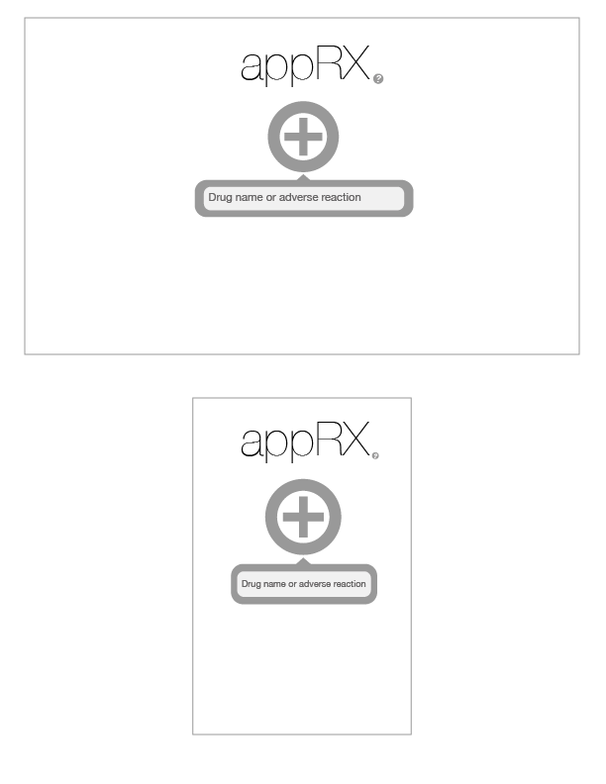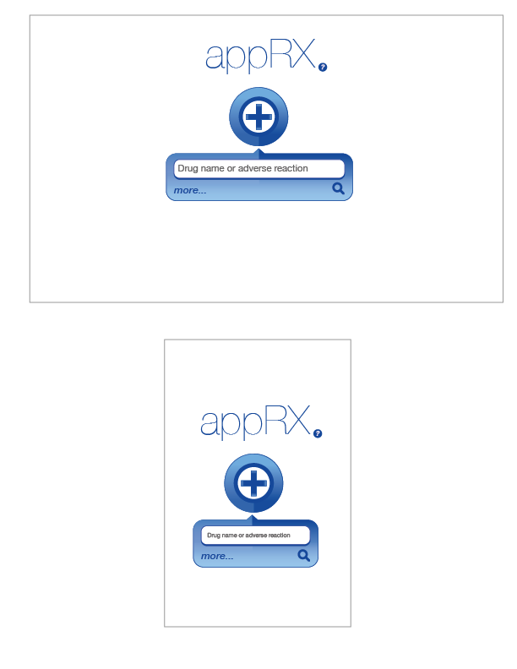

Home Page

* Nice clean look
* Very minimal
* Is AppRX the name? doesn’t communicate what the app does, pretty generic
* Is the plus a button or the logo?
* Not very colorful
* Not entirely clear what I am supposed to do.
* Can you enter multiple drugs or reactions, can you enter drugs and reactions at the same time?

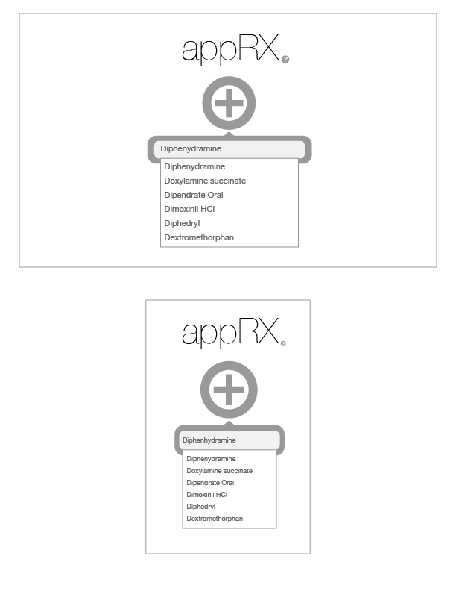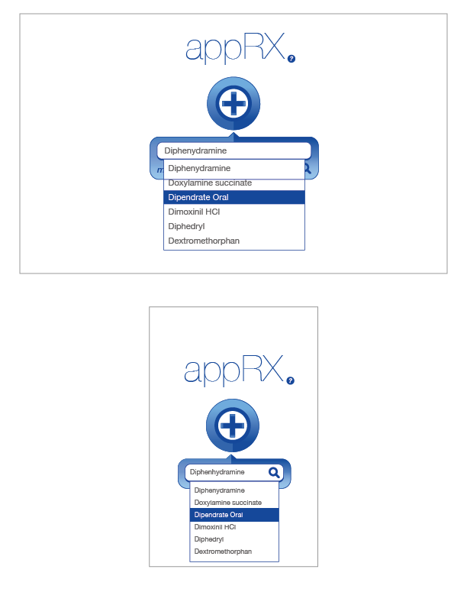

Search Entry

* Autocomplete is nice, Once I enter the search term how is the search triggered?
* What if I only know part of name?
* Looks good

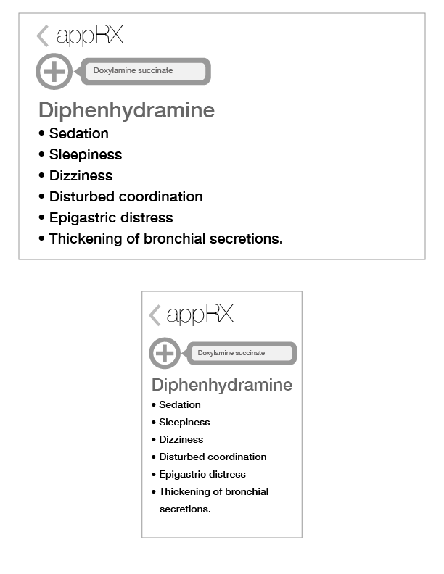 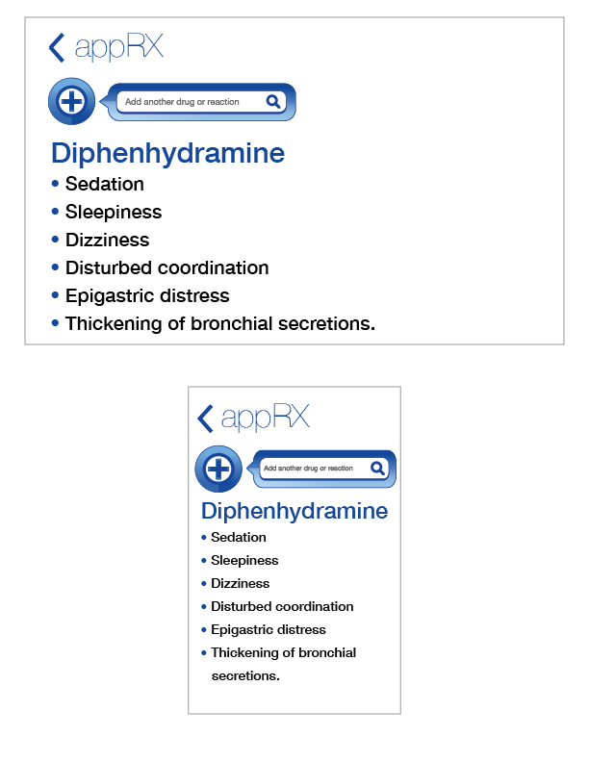

Adverse Reactions Search Results

* Pretty Basic, can I enter a second drug to search for?
* Is there any data available other than a list of reactions?
* How are they ordered?

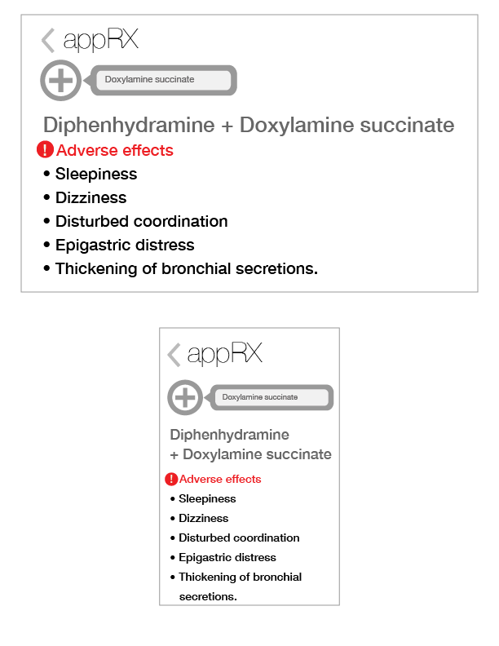

**Drug Search Results**

* The red font and exclamation mark look like an error indicator
* Is there any data available other than the drug names?
* How are they ordered? What happens if I enter a second reaction?

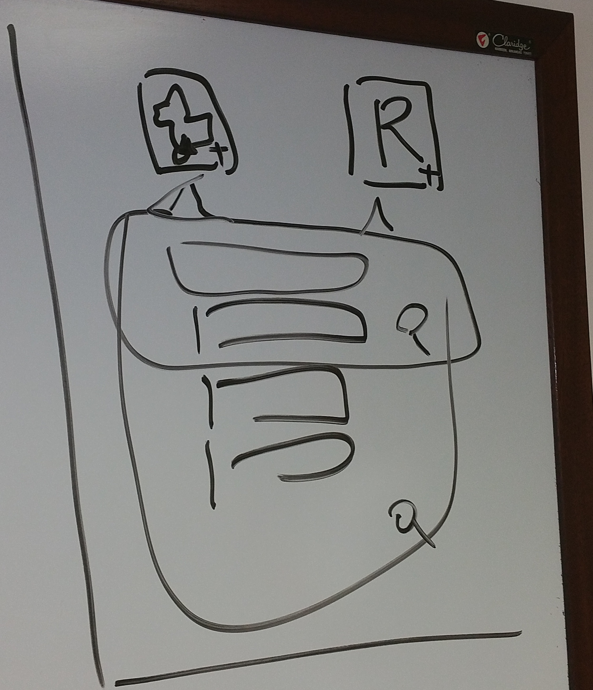

**Brainstorming on Whiteboard:**

* Should be able to select whether you are performing drug or adverse reaction search, shouldn’t be able to mix.
* Needs a graph link.
* Need a help page, a “?”
* Need to be clear you can enter multiple search terms…

**Initial Design Focus Group, 6/25**

**Objective:** Review initial mockups of application to discuss layout reactions and usability intuitiveness

**Focus Group Attendees**: Brandon Payne, Paul Yeh, Helen Zhou, Arya Salem, Thanh Dinh

**Project Team:** Kevin Sadeghian, David White, Phil Stroh, Paulo Ordoveza, Adelia Nichols, Ben Franzini

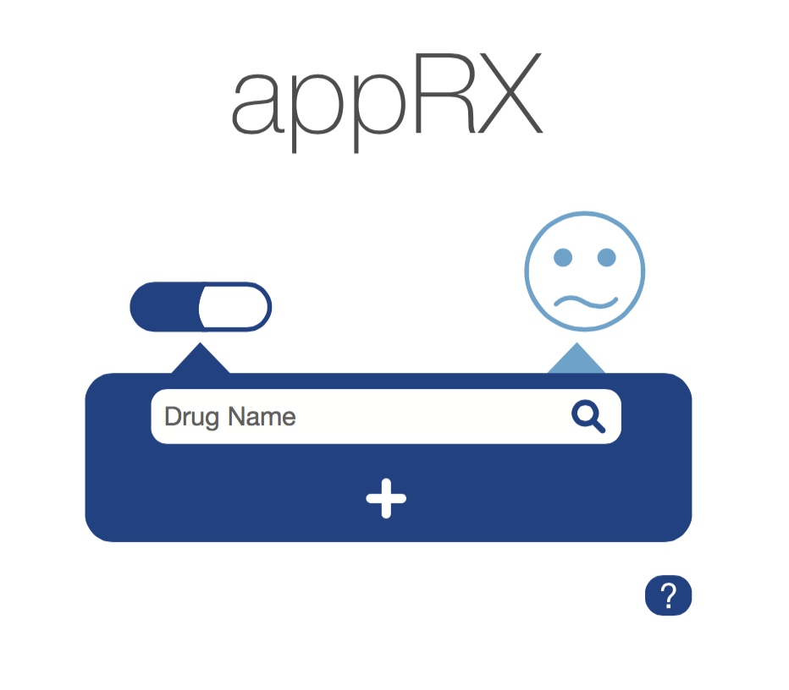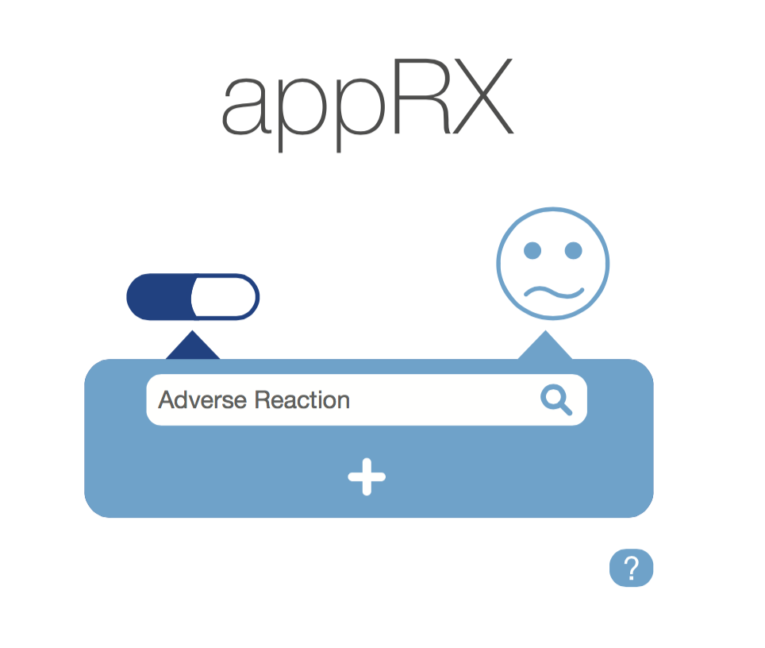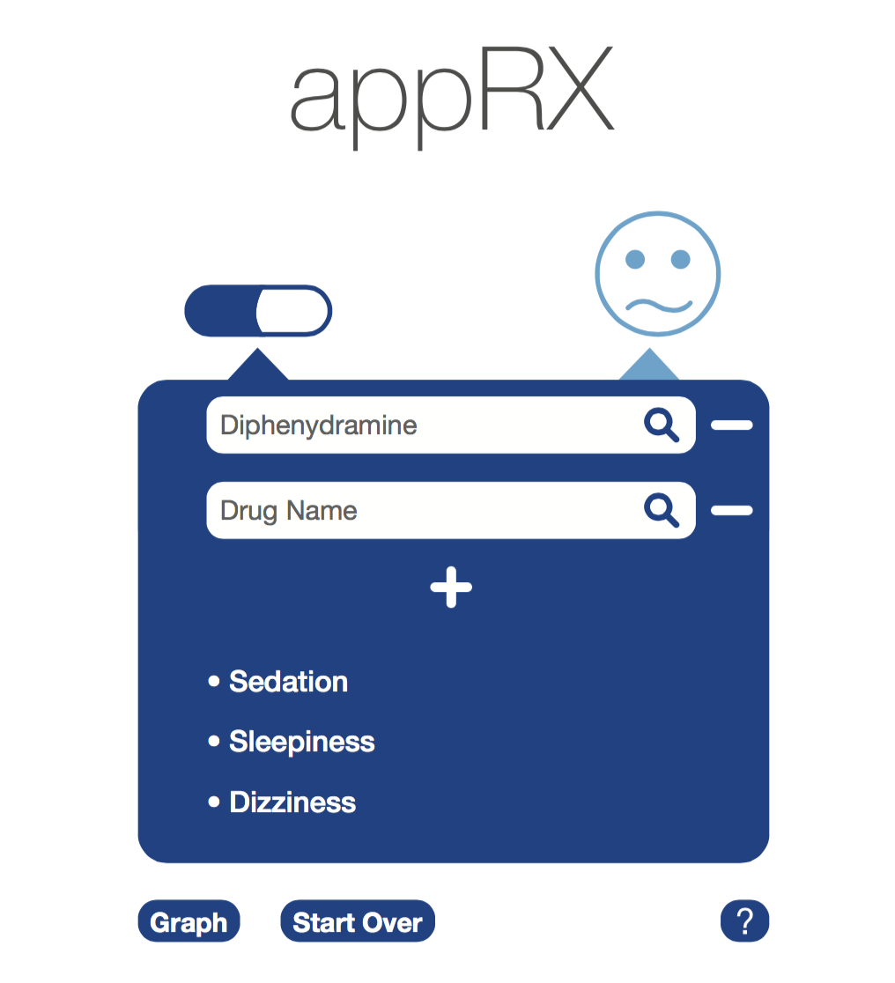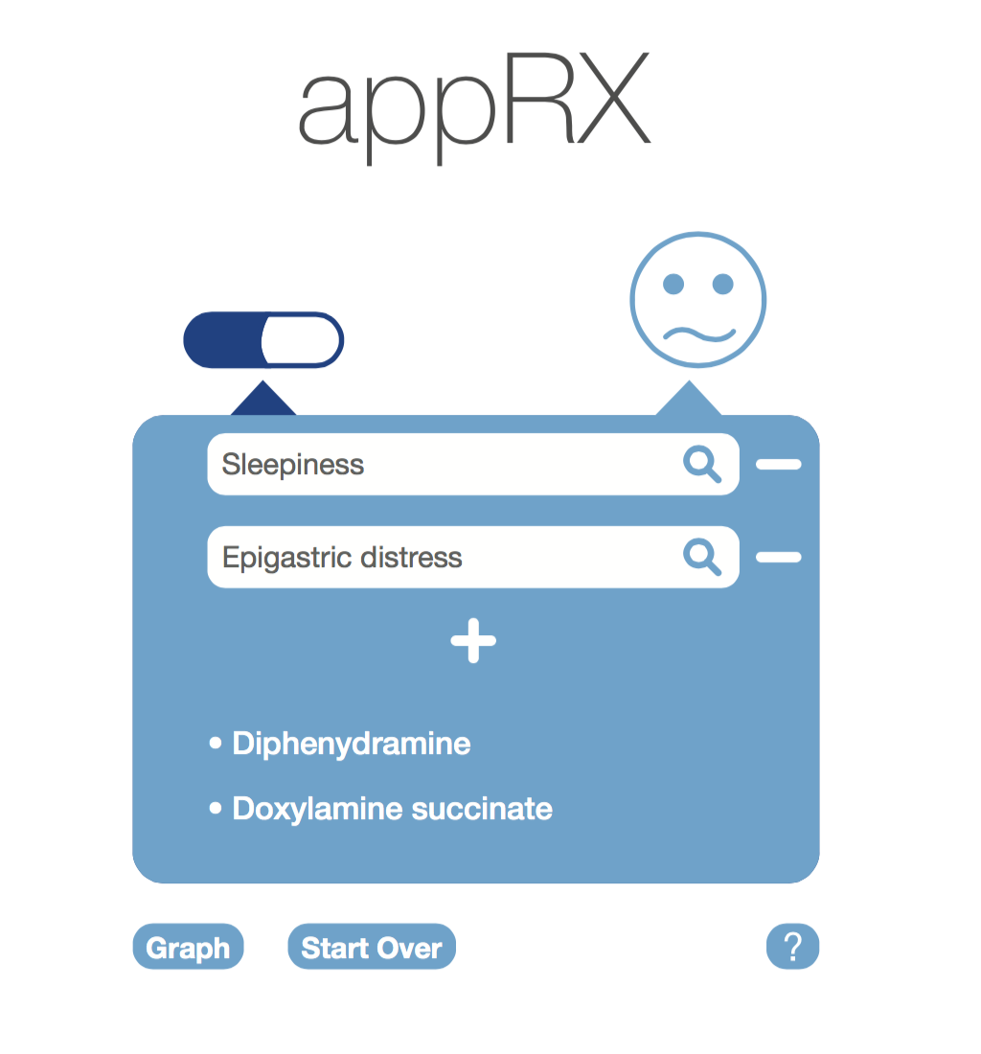

* Needs to say Statistics instead of Graph
* Change “start over” to “Reset”
* The ‘reaction face’ isn’t centered. See if it’ll look better centered.
* What’s the purpose of the magnifying glass within each search box? If the selection of a suggested text is triggering the search, the magnifying glass isn’t needed.
  + Instead, maybe you can have a microphone symbol (similar to google.com). this can come in handy on the mobile version of the app. Thoughts?
* Eliminate the period (.) at the end of “Thickening of bronchial secretions.” For consistency purposes
* Better name than appRX? (what does appRX suggest?)
  + either ReactionRX or RXreaction, or we can do something else
  + Need a more suggestive/creative name.
* “ReactionRX" or “rXReaction” - this helps communicate the primary function of the app. I agree that appRX doesn’t suggest ant specific function.
* The search results need some type of header explaining what they are (I.e. Adverse Reported Reactions Include" or Drugs That Led to Reaction: (possible in alternate blue color)), otherwise I think if you gave it to someone with no background they would have no context for what type of search results are being returned – especially because some of the drugs are indecipherable words.
* Would put the statistics button in the search results box to show it is a link related to the search results, just a thought.

**Initial Design Focus Group, 6/26**

**Objective:** Review initial mockups of application to discuss layout reactions and usability intuitiveness

**Focus Group Attendees**: Brandon Payne, Paul Yeh, Helen Zhou, Arya Salem, Thanh Dinh

**Project Team:** Kevin Sadeghian, David White, Phil Stroh, Paulo Ordoveza, Adelia Nichols, Ben Franzini

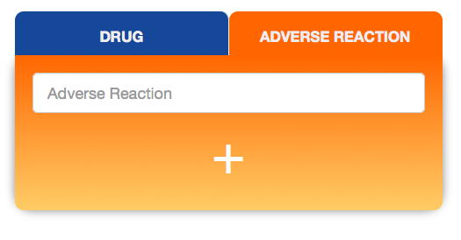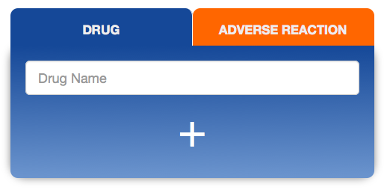

* I like clean look
* Going for text-based search selection is more intuitive but doesn’t look as flashy.
* Clear what to do.
* There's room for graphical elements over or under the text in those tabs if desired
* having the text labels really helps usability.



* New name communicates better what the application does.
* I like the logo, very simple